Scripting VStar

VStar permits some of its operations to be automated by writing a script:

- Loading observations from a file.
- Loading observations from the AAVSO International Database (AID).
- Switching between raw and phase plot mode.
- Creating a phase plot given a period and epoch.
- Saving a phase plot or light curve as a PNG image file.
- Saving a light curve to a data file.

The VStar API documentation should be consulted for full function details:

http://sourceforge.net/p/vstar/code/HEAD/tree/trunk/doc/vstar_docs.zip

It is intended that more functionality will be made available via the scripting API (Application Programming Interface) in future. The following gives a summary of the available API functions.

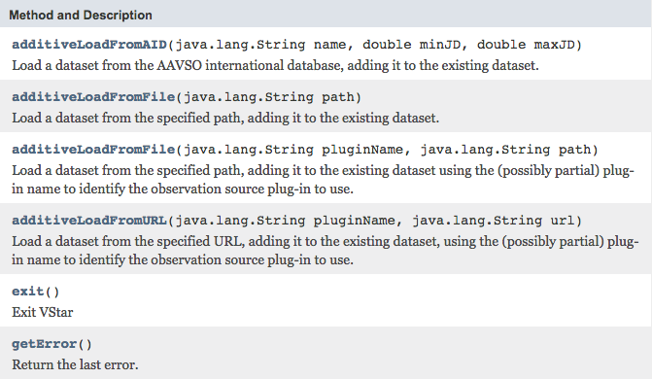
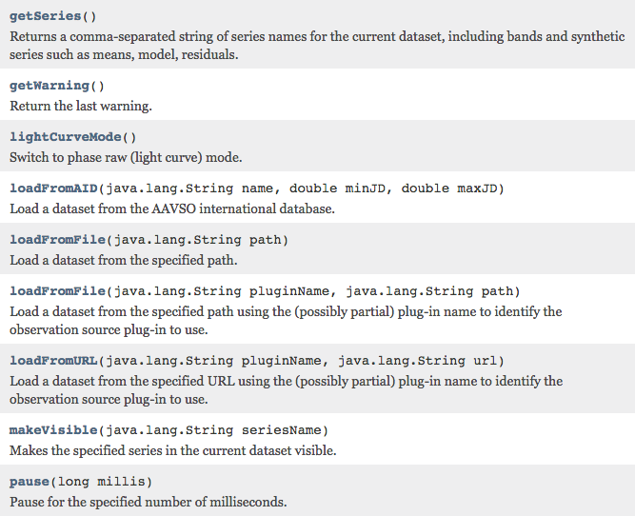
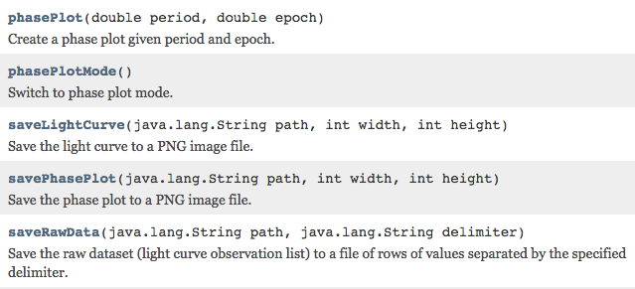

Currently, only the JavaScript language is supported but others may be permitted in future, such as Python or Ruby.

To run a script in VStar, select Tool → Run Script…



Doing so opens a file chooser requesting the script file to be executed.
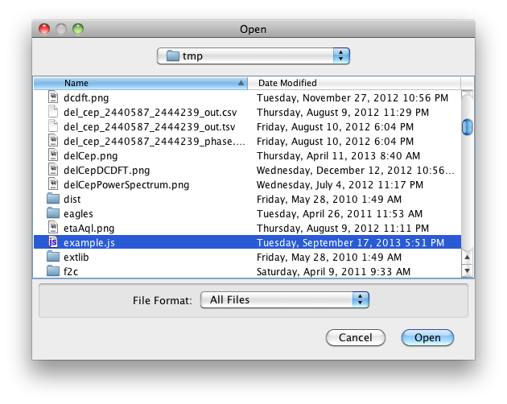
The file chooser shows example.js being selected. Clicking the Open button will cause the script to be executed. The example script will load data for eta Aquilae in the JD range 2455821.5...2456552.5, create a phase plot, and save it as a PNG file. It will repeat this for beta Lyrae.

To try this, create a file called example.js (or whatever name you choose) with a text editor (e.g. Notepad, vi), paste in the following code, and save the file.

root = "/Users/david/tmp/"

objs = ["eta Aql", "bet Lyr"]
periods = [7.176641, 12.94061713]
epochs = [2436084.656, 2455434.8702]

for (i=0;i<objs.length;i++) {
obj = objs[i]

vstar.loadFromAID(obj, 2455821.5, 2456552.5)

vstar.phasePlot(periods[i], epochs[i])

path = root + obj.replace(" ", "_") + "phase_plot.png"
vstar.savePhasePlot(path, 600, 400)
}

The root path should be replaced with a path of your choosing:

root = "/Users/david/tmp/"

Once the script has completed executing, you will see a phase plot for beta Lyrae appear in VStar and the following files will be in the location corresponding to the root directory:

bet_Lyr_phase_plot.png
eta_Aql_phase_plot.png

Opening the second of these will reveal a phase plot for eta Aquilae, as follows:

